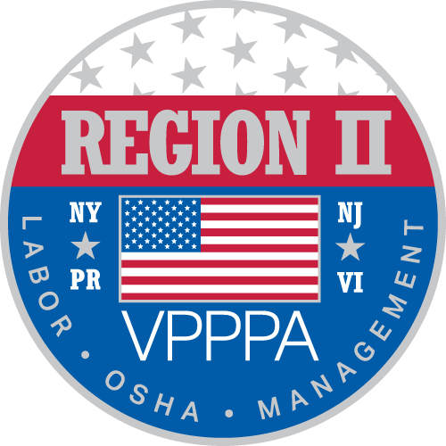

Voluntary Protection Program Participants’ Association ~ Region II Chapter
~~~~~~~~~~~~~~~~~~~~~~~~~~~~~~~~~~~~~~~~~~~~~~~~~~~~~~~~~~~~~~~~~~~~~~~~~~~~~~~~~~
~ Celebrating 26 Years of Excellence in Safety ~

This year is the Region II Voluntary Protection Program Participants’ 26th Year of Excellence in Safety. We are celebrating by hosting two separate safety forums. Participants will be able to choose which location is most convenient or choose to attend both forums. We are pleased to offer the Summer Forum June 25th and 26th in Atlantic City, New Jersey, and the Fall Forum October 1st and 2nd in Saratoga Springs, New York. For more information on our program, see www.vppparegion2.org.

The June 2018 forum will be held at the Tropicana Casino & Resort, 2831 Boardwalk, Atlantic City, NJ.
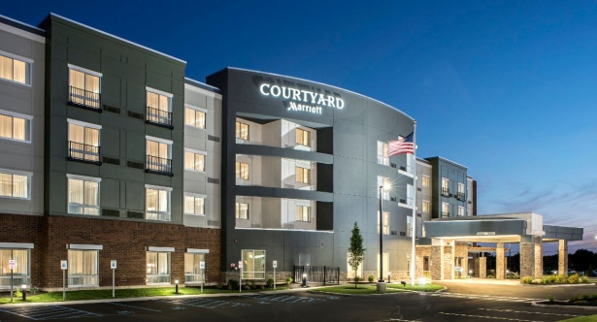
The October 2018 forum will take place at the Courtyard Marriott, Saratoga Springs, NY. Both forums will include a keynote speaker, as well as several speakers and/or organizations represented in the workshops.

LET YOUR COMPANY’S VOICE BE HEARD ~ AT ONE OR BOTH FORUMS ~ A LIMITED NUMBER OF BREAKOUT SESSIONS ARE AVAILABLE. THE COST IS $500.00 PER SESSION. YOUR COMPANY WILL LISTED IN OUR MAILER, ON THE WEBSITE & OTHER MEDIA, AND INCLUDED IN THE PROGRAM FOR THE CONFERENCE.

THIS IS A GREAT OPPORTUNITY TO HAVE YOUR BUSINESS IN THE SPOTLIGHT,

TELL US WHAT YOU’RE ABOUT, AND BENEFIT FROM

THE NETWORKING AVAILABLE IN THE PROCESS!

WHAT IS VPP? The VPP recognizes employers and workers in the private industry and federal agencies who have implemented effective safety and health management systems and maintain injury and illness rates below national Bureau of Labor Statistics averages for their respective industries. In VPP, management, labor, and OSHA work cooperatively and proactively to prevent fatalities, injuries, and illnesses through a system focused on: hazard prevention and control; worksite analysis; training; and management commitment and worker involvement. To participate, employers must submit an application to OSHA and undergo a rigorous onsite evaluation by a team of safety and health professionals. Union support is required for applicants represented by a bargaining unit. For more information visit us on the web.

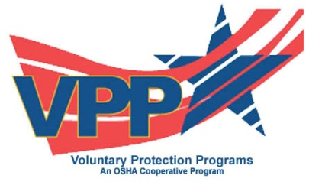
Brenda Wiederkehr, CSC
Chairman, Region II VPPPA

