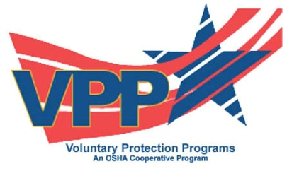
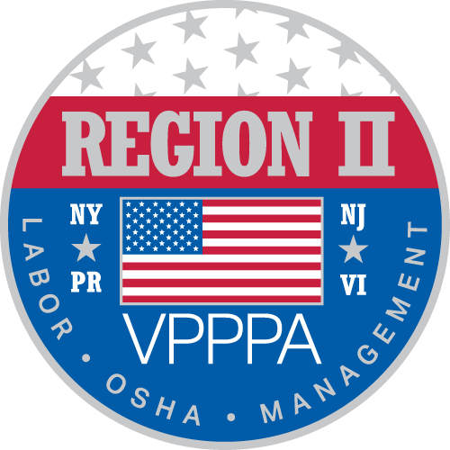

Voluntary Protection Program Participants’ Association
Region II Chapter

~ Spring 2016 Conference ~

An Exciting Opportunity for your company to Participate in BreakOut Sessions…

The Region II Voluntary Protection Program Participants’ 24th Regional Safety & Health 2016 Conference in Atlantic City, New Jersey, is coming up May 23rd through May 25th, 2016, with Workshops scheduled on May 26th, 2016. For more information on our program, see www.vppparegion2.org.

﻿﻿The 2016 conference will be held at the Tropicana Casino & Resort, 2831 Boardwalk, Atlantic City, NJ. Our annual conference includes a keynote speaker, as well as several speakers and/or organizations represented in the workshops.

LET YOUR COMPANY’S VOICE BE HEARD – A LIMITED NUMBER OF BREAK OUT SESSIONS ARE AVAILABLE FOR THIS YEAR’S CONFERENCE. THE COST IS $500.00 PER SESSION. YOUR COMPANY WILL LISTED IN OUR PROGRAM AND INCLUDED IN THE PROGRAM INSERT FOR THE CONFERENCE.

THIS IS A GREAT OPPORTUNITY TO HAVE YOUR BUSINESS IN THE “SPOTLIGHT”, TELL US WHAT YOU’RE ABOUT, AND BENEFIT FROM THE NETWORKING AVAILABLE IN THE PROCESS!

WHAT IS VPP? The VPP recognizes employers and workers in the private industry and federal agencies who have implemented effective safety and health management systems and maintain injury and illness rates below national Bureau of Labor Statistics averages for their respective industries. In VPP, management, labor, and OSHA work cooperatively and proactively to prevent fatalities, injuries, and illnesses through a system focused on: hazard prevention and control; worksite analysis; training; and management commitment and worker involvement. To participate, employers must submit an application to OSHA and undergo a rigorous onsite evaluation by a team of safety and health professionals. Union support is required for applicants represented by a bargaining unit. For more information visit us on the web.

Brenda Wiederkehr, CSC
Chairman, Region II VPPPA
Access Health Systems
776A Waterlviet Shaker Road
Latham, NY 12110
brenda@accesshealthsystems.com
info@vppparegion2.org

